
School Of Computing and Informatics
Website Design and Development
Assignment 1
Student Name: Rama Al Shababr
Student ID: 23110203
Section Number: 1
GitHub Link: lll
Website Link:

Contents
1. DNS 2
1.1 Types And Purpose Of DNS 2
1.2 How Domain Names Are Organised and Managed 2
2. Communication Protocols, Server Hardware, Operating System, And Web Server Software 3
2.1 Communication Protocols Definition 2
2.2 Relationship Between Protocols, Hardware, Operating System, Web Server Software 4
2.2.1 Purpose And Relationship 2
2.2.2 Relation To Designing, Accessing, and Publishing the Website 2
3. Website Development Technologies, Tools, Techniques, And Frameworks 2
3.1 Website Development Technologies 2
3.1.1 Available Website Technologies 3
3.1.2 Technologies Used to Design, Develop and Manage Your Website 3
3.2 Website Development Tools 3
3.2.1 Available Tools for Website Design and Development 3
3.2.2 Tools Used to Design and Develop Your Website 3
3.3 Website Development Techniques 3
3.3.1 Available Techniques for Website Design and Development 3
3.3.2 Techniques Used in Your Website 3
3.4 Website Development Frameworks 3
3.4.1 Available Frameworks for Website Design and Development 3
3.4.2 Frameworks Used in Your Website. 3
4. Search Engine Optimization 4
4.1 Search Engine Optimization Definition and Purpose 4
4.2 Indexing Definition 4
4.3 Techniques For Improving the Ranking 4
4.4 Evidence For the Used SEO Techniques in Your Website 4
5. Front-End And Back-End Website Technologies 4
5.1 Front-End And Back-End Definition and Related Technologies. 4
5.2 Presentation And Application Layers Definition. 4
5.3 Relationship. 4
6. Online Website Creation Tools VS Custom-Built Websites 4
6.1 Online Website Creation Tools 4
6.2 Custom-Built Websites 4
6.3 Comparison With Regards to Design Flexibility, Performance, Functionality, User Experience (UX) And User Interface (UI). 4
7. Design And Development Process 5
7.1 Website Vs. Design Document 5
7.2 Evaluation and Analysis 5
Hosting 5
References 5

DNS

Types And Purpose Of DNS

The Domain Name System (DNS) is a database that connects domain names to their corresponding IP addresses which is a unique number given to every device connected to the internet. It’s what makes browsing the internet so seamless by translating domain names that a human understands, like google.com or facebook.com, into the machine readable IP addresses that computers use to communicate. Without DNS, we’d have to remember numerical IP addresses to visit websites

Types of DNS:
- Recursive resolvers: this type of servers handles the clients’ requests by searching through other DNS servers until they find the requested IP address.
- Root: this type serve as the top of the DNS hierarchy as they direct requests to the suitable top level domain (TLD) servers
- TDL (top level domain): these servers are responsible for the top level domains, eg., “.com” ”.org” ”.net”
- Authoritative: these servers handle the final step in responding to the DNS requests/queries. They store and provide information about DNS records such as the domain names and their IP addresses.

How Domain Names Are Organised and Managed

When the user enters a domain name, “www.facebook.com” for example, a client like a web browser needs to find the corresponding IP address of that domain name so it sends a request to the DNS recursive resolver. If the DNS recursive resolver already has the wanted IP address stored in its cache it returns the information directly. If not, it starts the process of resolving the domain name.
It starts by contacting the root servers, these servers don’t give the specific domain’s IP address, however, they point the resolver to the authoritative name servers for the top level domain, in this case it’s “.com”
Then, the recursive resolver contacts the TLD servers for “.com”. TLD servers directs the resolver to the authoritative name servers for the second level domain, which is “facebook.com” here.
The resolver then connects to the authoritative name servers for “facebook.com” which have the IP address for “www.facebook.com“. Then, the authoritative server sends this IP address back to the resolver.
Finally, the recursive resolver caches the information for future requests and returns the IP address to the client, allowing the browser to connect the website.
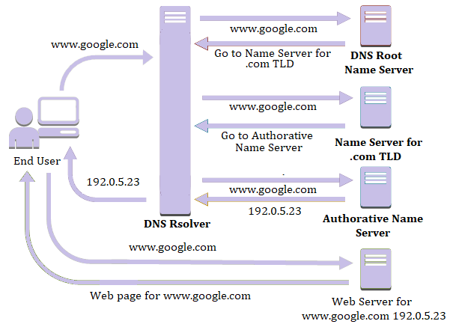

Communication Protocols, Server Hardware, Operating System, And Web Server Software

Communication Protocols Definition
Communication protocols are a set of rules or guidelines that define how data is exchange between systems. These rules determine the format and transmission of data and can be implemented through software and/or hardware.
HTTP: Hyper Text Transmission Protocol allows a client to establish a connection with a server by sending an HTTP request. The server then responds appropriately with an HTTP response. This process is essential for requesting and delivering web pages.
HTTPS: Hyper Text Transmission Protocol Secure same as the HTTP but the data transferred is in an encrypted format.
TCP/IP: Transmission Control Protocol is responsible for preparing and forwarding data packets across a network, ensuring reliable delivery. The Internet Protocol (IP), an addressing protocol, assigns IP addresses to these packets, guiding them through different network nodes until they reach their destination. Together, TCP and IP control the transmission of data packets across networks.
FTP: File Transfer Protocol is responsible for transferring computer files from a server to a client.
SMTP: Simple Mail Transport Protocol is an email protocol that is used for sending email messages from one email account to another via the internet
POP: Post Office Protocol responsible for receiving incoming E-mails
UDP: User Datagram Protocol is a transport layer communication protocol, particularly for video and audio traffic. Unlike TCP, UDP does not guarantee reliable delivery, making it faster and more suitable for real time applications where speed is critical.
DHCP: Dynamic Host Configuration Protocol is a network management protocol that automatically assigns an Internet Protocol (IP) address to any device on a network. This eliminates the need for manual configuration, making it easier to manage devices that connect to the network dynamically.

Relationship Between Protocols, Hardware, Operating System, Web Server Software

Purpose And Relationship
- Communication Protocols: as mentioned above, communication protocols provide rules for transmitting data from users to server hosting the web app
- Server Hardware: forms the foundation of the physical infrastructure required to host a web application. It includes essential components such as network interfaces, memory, storage devices, and processing units. This hardware must be strong enough to support the operating system, manage incoming requests, and run web server software effectively. Without reliable hardware, the operating system and web server software may struggle to perform efficiently.
- Operating System: acts as a bridge between the web server software and the server hardware, managing hardware resources to ensure smooth operation. It manage critical components like the CPU, memory, and storage to ensure tasks are executed efficiently.
- Web Server Software: When a user sends a request using protocols like HTTP, web server software like Apache or Nginx processes it. The server grabs the requested files (HTML, CSS, etc...) from its storage and sends them back to the client.
It also handles errors, like showing a 404 page when a file isn’t found. It takes care of encryption and decryption to ensure data is transferred securely, making sure it works smoothly with secure communication protocols like HTTPS.

The components work together seamlessly ensuring the delivery of an accessible, functional and responsive to user requests web application
Protocols handle how data gets routed and shared. Hardware brings the processing and storage power needed to make it all run. The operating system manages both hardware and software, making sure everything works well together. Finally, the web server software talks directly to the client to deliver web content

Relation To Designing, Accessing, and Publishing the Website

Designing: The way you get to an app, through a browser using HTTP depends on the communication protocols. The OS and web server software decide what programming tools you’ll use to build the app. The server hardware makes sure the app runs smoothly and can handle the load.
Accessing: When you open a website, HTTP or HTTPS handles how your browser talks to the server. While TCP/IP ensures the data gets where it needs to go and the server’s OS and hardware process everything efficiently
Publishing: to allow user access the DNS system turns the website name into the server's IP address. Using FTP, You can upload all your site files to the server. Web server software hosts the website files, making them available to users.

Website Development Technologies, Tools, Techniques, And Frameworks

Website Development Technologies

Available Website Technologies

      - Browser: Software used to access websites such as Chrome, Firefox, Safari and Edge.
      - HTML: stands for Hypertext Markup Language is the standard language for creating the structure of web pages
      - CSS: stands for cascading style sheets it is a style sheet language used to control the visual presentation of the HTML that we made (colors, fonts and position)
      - Programming languages
- java script: it is a scripting language the is responsible for adding interactive behaviour to the web page
- PHP: used for backend logic and dynamic web content
- Python: used for backend development with frameworks
- Java: backend language used in enterprise applications
      - Database (MySql, SQL server, oracle): organized data that's stored electronically and used by web apps to manage, retrieve, and show information dynamically
      - Frameworks: a built libraries that simplify and speed up the development process

Technologies Used to Design, Develop and Manage Your Website

in my website I used HTML to build the structure of the website then used CSS to style it from colors, fonts and positioning everything in its place. Javascript was used in the “showtimes” section in each movie, after picking the date the times show up then a “book now” button is showed after picking both the date and time. PHP was used for the backend development, the sign in and sign up, dynamically showing the movies. Database was created using SQL to save the movies, users and their activities.

Website Development Tools

Available Tools for Website Design and Development

- Codes and text editor: software like sublime, VS code and notepad++ are used to write codes and edit them efficiently
- Developer tools of the browser: built-in browser tools for inspecting and debugging web pages such as chrome devtools
- Tools for wireframing and sitemap: software like figma and AdobeXD are used to plan the layout of the website and its structure
- Version control: github for example is used to manage code versions and allow for collaboration
- Google search console : is a tool used to watch website performance in the search engines to improve SEO

Tools Used to Design and Develop Your Website
- Vs code was used to write the code edit them
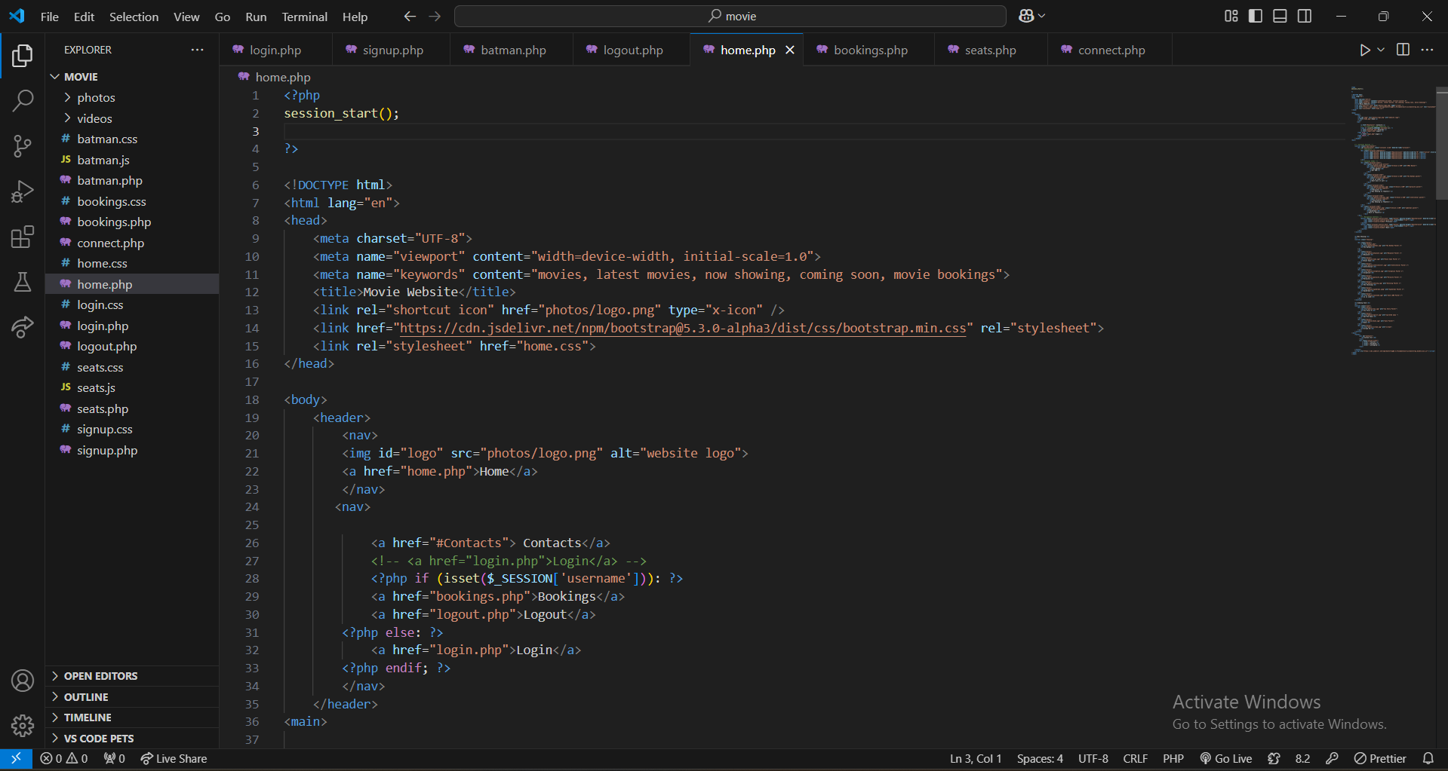
- Miro for sitemap and wireframe
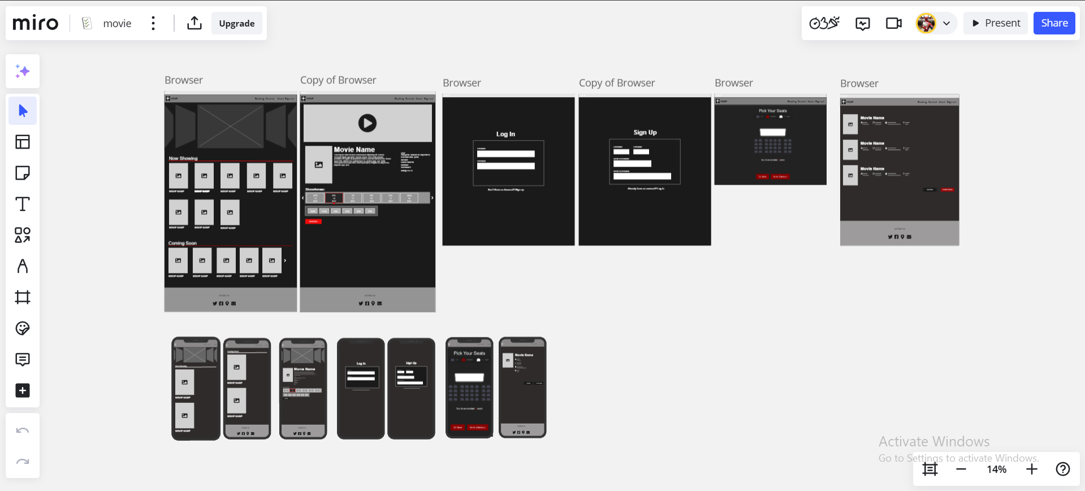

Website Development Techniques

Available Techniques for Website Design and Development
- Responsive design: this ensure that the website works well on different devices (desktops, phones and tablets)
- SEO techniques : as mentioned in part 4, this optimize the content and structure to improve search engine ranking
- Color palette: using appealing color schemes to improve visual aesthetics
- Good navigation: design menus and links for ease access to content
- Maintaining consistency across pages: maintaining a certain aesthetic through
- Using the title tag and favicon : Using descriptive titles and recognizable favicons to improve branding
- Mobile first: prioritize mobile experience during development
- Usability testing: testing the website for errors and ensuring a better experience for users

Techniques Used in Your Website

- Responsive design:
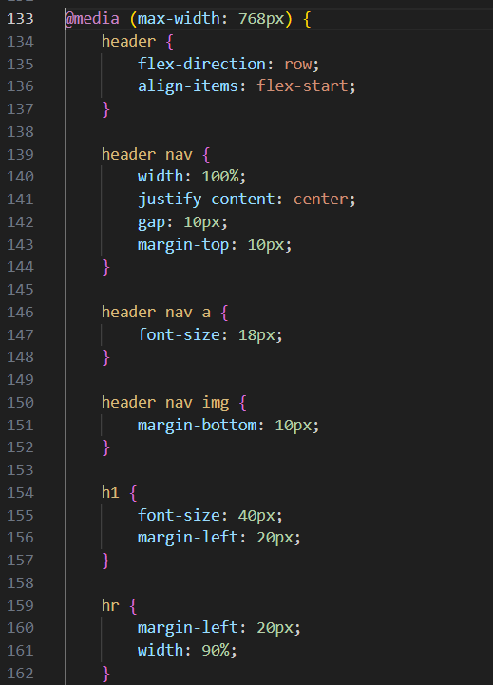
- SEO techniques:
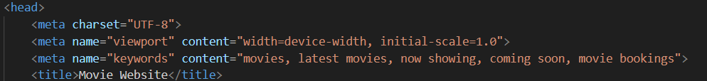
- Color palette: using websites like “color hunt” or “coolors” to find a good colors
- Using the title tag and favicon:
- Usability and testing: kept testing the website and created a testing document before publishing it
- Maintaining consistency across pages: all pages have a certain aesthetic

Website Development Frameworks

Available Frameworks for Website Design and Development
Frontend (HTML + CSS + JS)
        - Bootstrap: is a known CSS framework, it creates responsive design quickly
        - React.js: a javascript library, it builds user interfaces with reusable components by facebook
        - Angular.js: javascript framework for single page application by google
        - Font awesome: toolkit that helps you add logos and vector icons to your website
        - JQuery: javascript library that simplifies working with HTML
Backend
- PHP
- Laravel: A popular PHP framework known for being elegant and easy to use, with built-in features like routing and authentication.
- YII: A high-performance PHP framework ideal for building complex applications.
- C# : programming language used with the .NET framework to create powerful backend systems for enterprise-level projects
- Python (flask): Flask is a simple and lightweight Python framework that makes building web apps fast and flexible.
- Java (spring): A strong Java framework loaded with features like database access, security, and more, perfect for building robust applications

Frameworks Used in Your Website.

In my website a carousel bootstrap was used in the home page

The bootstrap was linked in the header for the css and after the footer for the js

Search Engine Optimization

Search Engine Optimization Definition and Purpose

Detention: SEO stands for Search Engine Optimization and it is the process of making the web pages more visible and rank higher on search engine results pages (SERPs). It involves structuring and crafting content in a way that helps search engines understand and prioritize it effectively so when the user search up certain words the website show up in the top results.
Purpose: The main purpose of SEO is to make a website more relevant and accessible for both users and search engines so we can achieve higher search rankings, boost engagement and drive more traffic to your site.
Using semantic HTML tags is essential for creating web pages that are search engine optimized. Tags like <nav>, <header>, <article> and <section> help search engines better understand and rank the content

Indexing Definition

Indexing is the process search engines use to analyze and store web page content in their databases. This allows them to retrieve and display relevant results when users perform a search
Metadata elements like <meta> tags are used to provide keywords, descriptions and other information that help search engines effectively index web pages.

Techniques For Improving the Ranking

- Semantic HTML: Semantic tags like <article>, <header>, <footer>, and <nav> provide a meaningful structure to the web page making it easier for search engines to understand.
- Meta Tags: Using <meta> elements for author information, descriptions, and keywords to enhance search engine indexing and improves discoverability.
- Title optimization: Titles should be concise (50–60 characters) and highly relevant. Each page should have a unique <title> tag as it plays a critical role in SEO
- Headings: Structured headings <h1> to <h6> define the content hierarchy which helps search engines and users understand the content of the page better.
- Content organization: Grouping related content with <section> or <article> tags ensures thematic relevance for both users and search engines.

Evidence For the Used SEO Techniques in Your Website
      - Meta tags in the head
      - Alt attributes for images
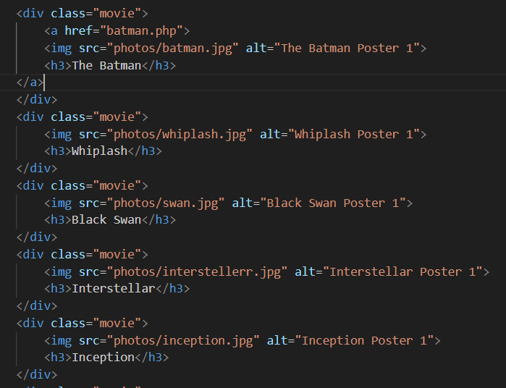
      - Semantic HTML structure (h1 for main title and h2 or h3 for subtitles and the use of <section>
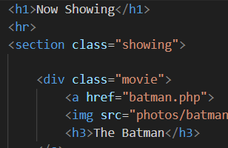

      - Favicon

Front-End And Back-End Website Technologies

Front-End And Back-End Definition and Related Technologies.

Front end:
The frontend is the part of a web app that users see and interact with directly. It’s all about the visual and interactive stuff on a website or app. The main tools and technologies used for front-end development are:

- HTML: This structures the content on a webpage.
- CSS: Handles the layout and design, making things look good.
- JavaScript: Adds dynamic features and makes websites interactive.
- Frameworks and Libraries: Tools like React, Angular, Vue.js, and Bootstrap make development faster and add cool features.

Back end:
The backend is the back part of an app that handles logic, database, and server functionality. It’s like the brain of the app, making sure the front-end gets the right data and works properly. Here’s what’s usually used for the back-end:

- Programming Languages: like Python, PHP, Java, Ruby, and C#.
- Frameworks: Examples include Express.js, Laravel, Flask, and Spring Boot.
- Databases: SQL ones like MySQL

Presentation And Application Layers Definition.
Presentation Layer: Is the front-end of a web app. Its job is to show info to users and let them interact with it in a simple and user-friendly way. The main focus is to make the user experience smooth and visually appealing.
Application Layer: This is like the back-end of a web app. It handles all the data processing, business logic, and connections to databases or other systems. It makes sure everything works properly and processes user requests the right way.

Relationship.

The front-end and back-end work together to create a smooth and functional web app experience, connecting the presentation and application layers seamlessly.
- Data Flow: The back-end processes data and sends it to the front-end for users to see. For example, in an e-commerce site, the back-end grabs product info from a database, and the front-end displays it to the user.
- Interactivity: User actions on the front-end, like clicking buttons or filling out forms, send requests to the back-end using HTTP or APIs. The back-end processes these and sends back the needed data or performs the action.
- Technology Integration: Front-end tools often use APIs to talk to back-end frameworks. This connects the two layers and ensures everything runs smoothly.
- Scalability and Maintenance: Keeping the front-end and back-end separate makes it easier to update or fix one without messing up the other.
In conclusion, the presentation and application layers rely on each other. This setup ensures great performance, a better user experience and a system that’s easy to scale and maintain.

Online Website Creation Tools VS Custom-Built Websites

Online Website Creation Tools
Online website builders are tools that make it super easy to create websites without needing coding skills. They usually come with templates and drag-and-drop features, which is awesome for small businesses or people on a budget. Examples include Wix, Squarespace, and WordPress.com.
Advantages
- You can set up a site really fast.
- They’re affordable for basic needs.
- They come with built-in stuff like hosting, SEO tools, and analytics.
- The platform takes care of updates and maintenance, so you don’t have to.
Disadvantages
- Customizing is kind of limited because you’re stuck with their templates and features.
- You’re dependent on their pricing and system.
- If you’re trying to build a super complex or interactive site, it might not perform as well

Custom-Built Websites

Custom websites are built from scratch by web developers or teams using programming languages like HTML, CSS, and JavaScript, along with backend tech like PHP, Python, or Node.js. These sites are usually made for specific business needs and come with advanced features.
Advantages:
- Complete design freedom to create unique layouts that match a brand.
- Better performance because the code is optimized.
- Can easily scale to fit business growth or changes.
- More secure thanks to custom updates and configurations.
Disadvantages:
- Takes more time and costs more to develop.
- You need technical skills to maintain and update it.
- Hosting, updates, and scalability are separate tasks you need to manage.

Comparison With Regards to Design Flexibility, Performance, Functionality, User Experience (UX) And User Interface (UI).

Aspect | Online website builders | Custom built websites
Flexibility in design | Limited to pre-made templates with minor customizations | Fully customizable; tailored designs for unique branding.
Performance | Moderate; uses general optimizations and shared hosting. | High; optimized for speed and resource efficiency.
Usability | Standard features | Advanced functionality tailored to specific needs.
User experience | Simple and suitable for small-scale projects. | Comprehensive, flexible, and scalable for all user types.
User interface | Generic but consistent; template-based structures. | Unique, engaging, and aligned with brand identity.

Design And Development Process

Website Vs. Design Document

Evaluation and Analysis

The development of the website was guided by the original design document, ensuring the final product stayed true to its initial concept. However, during development, a few minor adjustments were made to enhance the user experience and streamline the overall functionality. These changes improved the organization and usability of the site while maintaining its core logic and purpose.

One major update was made to the checkout page. In the original design document, there were two separate buttons: one to confirm reservations and another to modify the user's selection by going back to the page before it. Then, users were expected to return to the home page through the navigation bar. To simplify the process, these functions were combined into a single button that not only confirms the reservation but also redirects users back to the main page, letting them continue browsing seamlessly. Additionally, each reservation now features an "edit" and “delete” button next to it, allowing users to modify or delete their reservations directly. This change makes the interface more intuitive and efficient without overwhelming the user.

Another significant adjustment was the removal of the seating page, which was initially included in the design document. After evaluating its relevance and usefulness, it was decided that the seating page was not functional and only added clutter to the interface. Eliminating it resulted in a cleaner and more focused user experience.

Other refinements included minor structural and visual updates to improve accessibility and align the website's design with modern trends. For example, button placement and navigation flow were optimized to reduce the number of clicks required for common tasks. Typography and color schemes were also slightly tweaked to improve readability and create a visually engaging experience.

Overall, the adjustments made during development were driven by practical considerations. While the design document provided the foundation, the development process allowed for iterative improvements that enhanced the site’s functionality and user experience without deviating from its original purpose. These changes highlight the importance of flexibility and user-focused design in creating a successful and practical website.

Hosting (Add your domain and URL)
Add your domain and URL
Specify which hosting server you use
Add screenshots

References

- Ivanova, I. (2024). Ultimate Front End Technologies Guide with List of Top Tech. [online] Designrush.com. Available at: https://www.designrush.com/agency/software-development/trends/front-end-technologies [Accessed 15 Jan. 2025].
- Arpit Mehar (2023). Almabetter. [online] AlmaBetter. Available at: https://www.almabetter.com/bytes/articles/backend-technologies [Accessed 15 Jan. 2025].
‌

‌

